ONLINE COMPUTER STORE

Project on
“Online Computer Store”
In partial Fulfillment of the Requirement for Award of the Degree of
BACHLOR OF BUSINESS ADMINISTRATOR

(COMPUTER APPLICATION)
Mr. Mane Rohit Bapu Roll No: - 39 Exam Seat No: -

Mr. Takale Partik Anil Roll No: - 80 Exam seat No: -



Project Guide: - Mr. Anil Kalokhe
VIDYA PRATISHTAN’S
ARTS SCIENCE & COMMERCE COLLEGE,
VIDYANAGARI, BARAMATI – 413133
SAVITRIBAI PHULE PUNE UNIVERSITY, PUNE
TYBBA(CA) (SEM-V) 2025-2026

VIDYA PRATISHTHAN’S

ARTS, SCIENCE & COMMERCE COLLEGE
VIDYANAGARI, BARAMATI -413133


CERTIFICATE
DEPARTMENT OF COMPUTER APPLICATION
This is to certify that Mane Rohit Bapu and Takale Pratik Anil TYBBA(CA)
(SEM-V) has satisfactory carried out the project work according to the Syllabus prescribed by the University of Pune in COMPUTER APPLICATION and this
project represents his Bonafide work in the year 2025 to 2026.

Roll No:39 Exam Seat No:

Roll No: 80 Exam Seat No:
____________ ____________

Batch In charge H.O.D.

Date: / / 2025 Date: / / 2025
____________ ____________

Internal Examiner External Examiner
Date: / / 2025 Date: / / 2025

VIDYA PRATISHTHAN’S

ARTS, SCIENCE & COMMERCE COLLEGE
VIDYANAGARI, BARAMATI -413133


CERTIFICATE
DEPARTMENT OF COMPUTER APPLICATION
This is to certify that Mane Rohit Bapu TYBBA(CA) (SEM-V) has satisfactory carried out the project work according to the Syllabus prescribed by the University of Pune in COMPUTER APPLICATION and this project represents his Bonafide
work in the year 2025 to 2026.

Roll No:39 Exam Seat No:

____________ ____________

Batch In charge H.O.D.

Date: / / 2025 Date: / / 2025

____________ ____________

Internal Examiner External Examiner
Date: / / 2025 Date: / / 2025

VIDYA PRATISHTHAN’S ARTS, SCIENCE & COMMERCE COLLEGE
VIDYANAGARI, BHIGWAN ROAD, BARAMATI, DIST-PUNE-413133



CERTIFICATE
DEPARTMENT OF COMPUTER APPLICATION
This is to certify that Takale Pratik Anil TYBBA(CA) (SEM-V) has satisfactory carried out the project work according to the Syllabus prescribed by the University of Pune in COMPUTER APPLICATION and this project represents his Bonafide
work in the year 2025 to 2026.

Roll No: 80 Exam Seat No:

____________ ____________

Batch In charge H.O.D.
Date: / / 2025 Date: / / 2025

____________ ____________

Internal Examiner External Examiner
Date: / / 2025 Date: / / 2025

INDEX
Sr. No | Contents
Ch 1 | Introduction
1.1 | Abstract
1.2 | Introduction to System
1.3 | Company Profile
1.4 | Scope of the System
1.5 | Proposed System
Ch 2 | System Analysis
2.1 | Fact Finding Techniques
2.2 | Feasibility Study
2.3 | Hardware & Software Requirements
Ch 3 | System Design
3.1 | Entities & Attributes
3.2 | Entity Relationship
3.3 | E-R Diagram
3.4 | Context Level Diagram
3.5 | Data Flow Diagram
3.6 | Second Level DFD
Ch 4 | File Design
4.1 | Data Dictionary
4.2 | Data Flow
4.3 | Data Store
4.4 | Data Process
Ch5 | Table Design
Ch 6 | Form Design
Ch 7 | Report
Ch 8 | Advantages & Disadvantages
Ch 9 | Future Enhancement
Ch 10 | Bibliography

Online computer store

Chapter no.1
INTRODUCTION
VPASC Baramati |  | 7

1.1) Abstract:-
The Online Computer Store is a web-based e-commerce platform designed to provide customers with a seamless shopping experience for computer systems, accessories, and related electronic products. The system allows users to browse and search products, view detailed specifications, compare options, and place orders securely. Integrated features such as product filtering, cart management, user authentication, and online payment ensure a smooth and efficient purchasing process. On the backend, administrators can manage product listings, update inventory, process orders, and monitor sales performance. This platform leverages modern web technologies to deliver a responsive, scalable, and user-friendly solution that bridges the gap between customers and computer hardware suppliers.

1.2) Introduction to System: -
The Online Computer Store is an advanced e-commerce application designed to simplify the process of purchasing computers, laptops, and related accessories. With the growing demand for digital shopping platforms, this system provides customers with a convenient way to explore, select, and purchase products from the comfort of their homes.
The system is divided into two primary modules: User Module and Admin Module.
The User Module enables customers to register, log in, search products, filter by brand or category, view detailed product descriptions, add items to the shopping cart, and place secure online orders. It also supports order tracking and review submissions to enhance customer engagement.
The Admin Module provides store administrators with tools to manage inventory, add or update product details, handle customer orders, and monitor sales reports.

1.3) Company Profile: -
Online Computer Store is a web-based retail platform dedicated to providing customers with a wide range of computer systems, laptops, peripherals, and accessories. The company focuses on delivering a convenient, secure, and user-
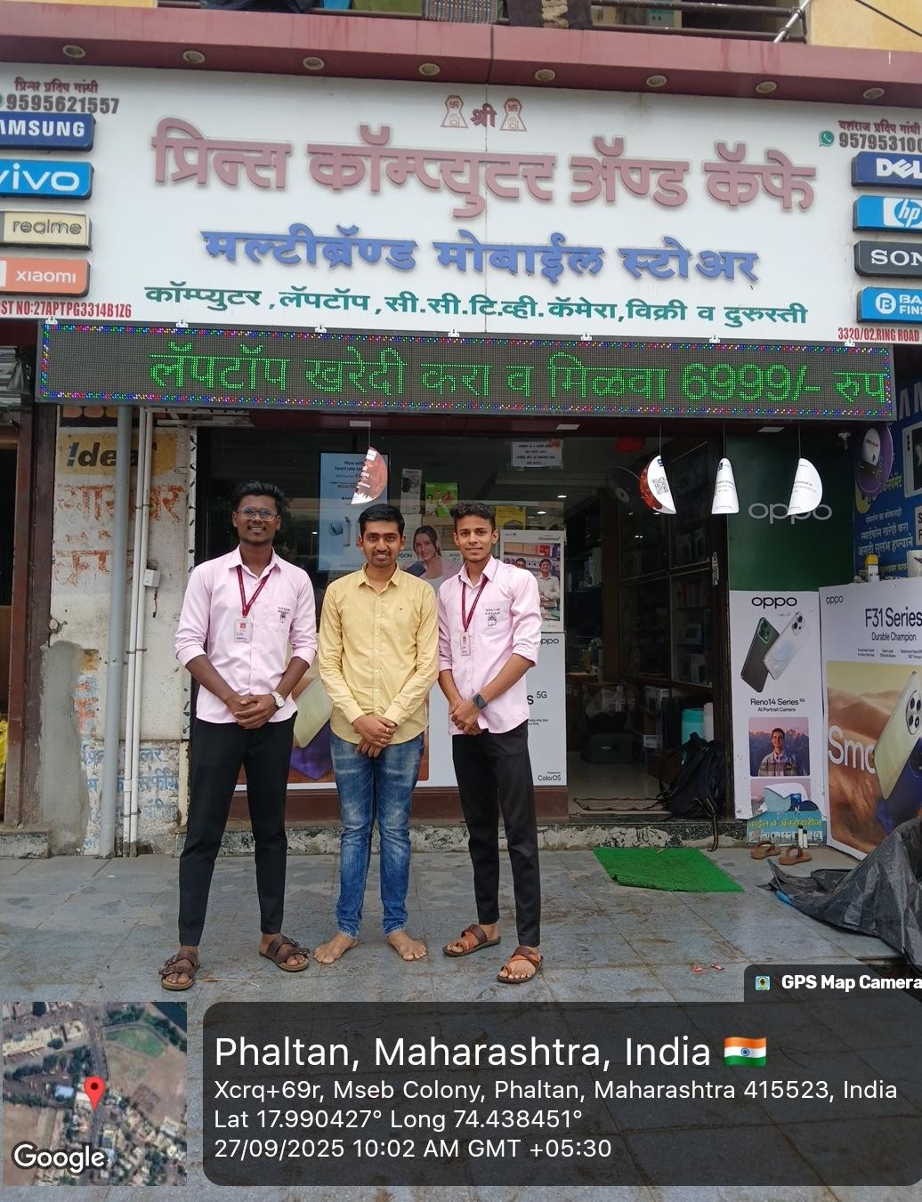
Online computer store

VPASC B
aramati

9

friendly online shopping experience, ensuring that customers can access the latest
technology products at competitive prices.

1.4) Scope of the System: -
The scope of the Online Computer Store defines the overall boundaries, objectives, and functionalities of the system. It covers the services provided to customers, as well as the administrative features available for store management.
System Scope:
- Provides a web-based platform accessible from desktops, laptops, and mobile devices.
- Ensures data security using authentication and authorization mechanisms.
- Integrates with cloud services (e.g., Cloud nary) for product image storage.
- Offers scalability to accommodate an increasing number of users and products.
- Maintains a responsive and user-friendly interface for smooth navigation.

1.5) Proposed System: -
The Online Computer Store is proposed as a complete e-commerce platform that overcomes the limitations of traditional shopping methods and existing manual systems. The system aims to provide a reliable, efficient, and user-friendly solution for both customers and administrators.

Online computer store

Chapter No.2
ANALYSIS
VPASC Baramati |  | 11

2.1 FACT FINDING TECHNIQUES: -
To analyze and design the Online Computer Store, various fact-finding techniques were used to gather information about user requirements, system functionalities, and existing problems with traditional/manual methods. The techniques used are as follows:
There are four types of fact-finding techniques: -

2.1.1 Interview: -
We conduct this technique because interview is very important data gathering techniques as in this the analyst directly contacts system and the potential user of the proposed system.
The interviews are of two types
1 Structured interview
2. Unstructured interview

i) Structured interview: -
These interviews are conduct because structured interviews are those where the interviewee is asked a standard set of questions in a particular order. All interviewees are asked the same set of questions.
- Do you prefer shopping for computers and accessories online or in physical stores? Why?
- What features would you expect in an online computer store (e.g., product comparison, reviews, filters)?
- How important is secure online payment for you when shopping online?
- Which device do you usually use for online shopping (desktop, laptop, or mobile)?
- Would you like to track your order after purchase?

ii) Unstructured Interview: -
This interview we conduct on undertaking in a question-answer format. This is of a much more flexible nature than the structured interview and can be very rightly used to gather general information about the system.

Here the respondents are free to answer in their own words. In this way their views are not restricted. So, the interviewer gets a bigger area to further explore the issues pertaining to a problem.
For ex.
- Can you describe your experience when buying a computer or accessories online?
- What problems have you faced while purchasing from physical stores or existing websites?
- What features do you feel are missing in current online computer stores?
- If you could design an online store yourself, what would you include in it?
•How do you decide which computer or accessory to buy (reviews,
specifications, price, brand)?

2.1.2 QUESTIONNAIRE: -
To gather detailed information from potential customers and administrators regarding the requirements of the Online Computer Store, a questionnaire was designed. This questionnaire helped in identifying user preferences, challenges, and expectations from the system.
A. Open ended questionnaire:
Open-ended questionnaires are useful to capture feelings, opinions, general experiences, and problems faced by users and administrators.
1. Can you describe the process you go through when selecting computers or accessories to purchase online?
- Researching latest technology trends
- Reading online reviews and specifications
- Asking for recommendations from friends/experts
- Comparing different brands and prices
2. How do you think the computer shopping experience has changed in recent years, and what trends are you most excited about?
- Rise of online shopping platforms
- Availability of diverse brands and models
- Growing demand for budget-friendly devices
- Increased importance of fast delivery and service
3. What types of customer feedback have you found most valuable in shaping product offerings in an online computer store?
- Performance and specifications feedback
- Price sensitivity and affordability
- Quality and durability of products
- Overall shopping experience (website usability, delivery, etc.)
4. How do you usually interact with an online computer store, and what makes you trust the platform?
- Detailed product descriptions and images
- Verified customer reviews and ratings
- Secure payment options
- Efficient customer support and return policies
5. What challenges have you faced while shopping for computers or accessories online, and how do you usually deal with them? A) Difficulty in comparing multiple products
- Concerns about product quality or originality
- High shipping costs or delays
- Lack of proper customer support after purchase
B. Close-Ended Questionnaire –
Close-ended questionnaires control the frame of reference by presenting predefined options for respondents to select.
1. Do you feel the current process of purchasing computers and accessories online needs improvement?
A) Yes B) No
2. Would you like an online computer store to offer discount coupons or promotional offers?
A) Yes B) No
3. Do you think having eco-friendly and energy-efficient computer products is important?
A) Yes B) No
4. Would you prefer live chat or customer support assistance while shopping online?
A) Yes B) No
5. Should an online computer store provide multiple secure payment options (Credit/Debit, UPI, PayPal, COD)?
A) Yes B) No

2.1.3 OBSERVATION: -
Observation is one of the most effective fact-finding techniques, as it helps to directly study user behavior, existing processes, and challenges in the shopping experience. By carefully observing both customers and administrators, important requirements for the Online Computer Store system were identified

2.1.3.1 RECORD VIEW: -
Record review is an important fact-finding technique that involves examining existing documents, reports, and records to gather useful information for system analysis and design. For the Online Computer Store, various records were reviewed to understand the existing processes, data flow, and requirements.
- Sales Records:
  - Past invoices and receipts were studied to understand the structure of sales transactions.
  - Information such as product name, quantity, price, discount, tax, and total bill amount helped in designing the order and billing module.

- Product Catalogs:
  - Existing product catalogs and brochures were reviewed to identify the required product attributes (e.g., brand, model, specifications, price, and warranty).
  - Helped in deciding the database fields for product management.
- Customer Records:
  - Customer details from registration books and old records were reviewed.
  - Helped in identifying the necessary fields for customer profiles (e.g., name, email, phone, address, past purchases).
- Financial & Payment Records:
  - Payment records such as cash receipts, credit/debit card slips, and online payment confirmations were studied.
  - Highlighted the need for multiple secure payment options in the proposed system.

2.2 Feasibility Study: -
Feasibility study carried out whether there is complex problem. The purpose of feasibility study to investigate deeply the recommended system. Feasibility study is carried out to describe and evaluate the proposed system.
The study will justify whether the project is feasible or not and whether it is worthwhile or not?
There are three aspects of feasibility study.
- Technical feasibility
- Economic feasibility
- Operational feasibility

2.2.1 Technical feasibility: -
Technical feasibility evaluates whether the proposed Online Computer Store can be developed using the available hardware, software, and technical resources. It ensures that the system is technically practical and can be implemented with the chosen technologies.

Hardware Requirements: -
Processor: - Intel ® Core 2duo.
RAM :- 8 GB.
HDD:-400 GB.

Software Requirements:- Operating System: - ANY
Front End: React.js, Tailwind CSS.
Back End: Node.js Express.js.
Database: MongoDB

2.2.2 Economical Feasibility: -
In an Economic Feasibility study, the cost and benefits of the project are analyzed. This involves a detailed examination of the expenses required for system development, including hardware, software, design, development, and operational costs. Afterward, it is determined whether the project will be financially beneficial for the organization.
The Online Computer Store has been developed using open-source technologies like MongoDB, Express.js, React.js, and Node.js (MERN stack), which reduces the overall cost of development. Since most of the required tools are free and opensource, the system can be implemented in a short period with minimum investment.
There are two types of economical feasibilities:
- One-time cost: -
Software - 50000 RS
- Recurring cost: -
Service and maintains – 6000rs

2.2.3 Operational feasibility: -
Operational feasibility focuses on ensuring that the Online Computer Store works smoothly in real-world conditions without errors or complications. It measures how effectively the proposed system solves existing problems and supports the business objectives. This feasibility also ensures that the system provides security, reliability, and usability for both customers and administrators.

Online computer store

Chapter no.3
System Design

VPASC Baramati |  | 18

Entity & Attribute

Sr. no | Entity | Attribute
1 | Customer | c_ id, c_ name, c_ address, c_ phone, c_ email
2 | Admin | a_ id, a_ name, a_ email, a_ phone
3 | Category | C_ id, cat_ name, cat _desc
4 | Review | rid, rating, r_ text, r_ date, c_ id, p_ id
5 | Product | p_ d, p_ name, p_ price, p_ model
6 | Order | o_ id, o_ date, o_ status, o_ type
7 | Bill | b_ no, b_ date, Gst _no, total
8 | Cart | Cart_ id, qty, added _date, c_ status, c_ id, p_ id

3.2 Entity & Relationship

Sr. no | Entities | Relationship
1 | Customer – Admin | One to One
2 | Customer – Review | Many to Many
3 | Customer – Category | One to Many
4 | Customer – Bill | One to One
5 | Admin – Bill | One to Many
6 | Category – Product | One to Many
7 | Product – Cart | Many to One
8 | Product – Review | One to Many
9 | Product – Order | One to Many
10 | Cart – Order | One to One
11 | Order – Bill | One to One

3.3 Entity Relationship

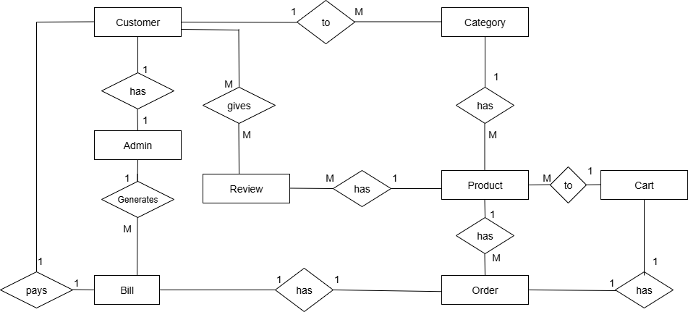

UML DIAGRAM 1.Class diagram:
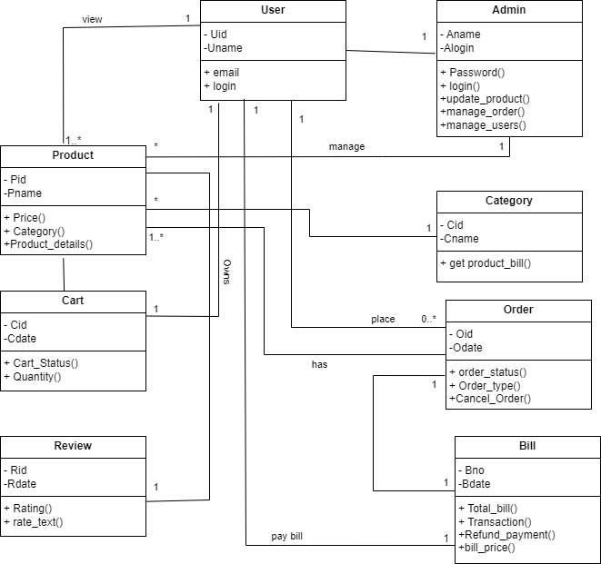

2.Object diagram:
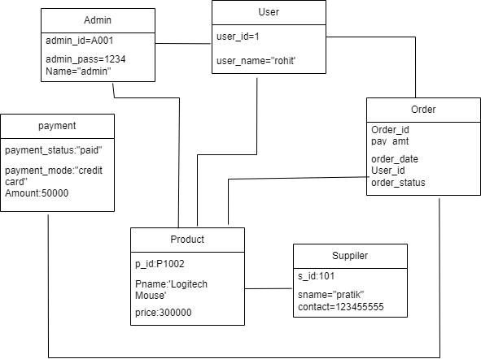

3.Use-Case Diagram

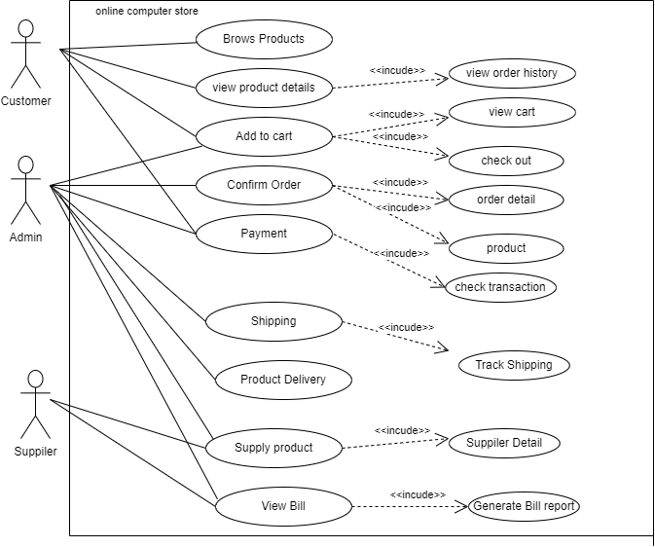

4.Sequence Diagram: -

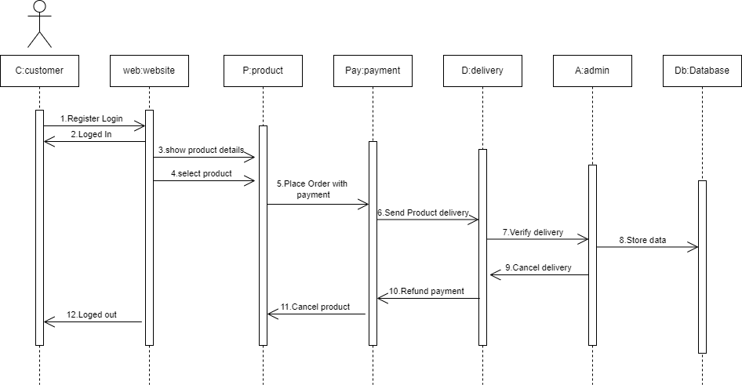

5.Component Diagram:-

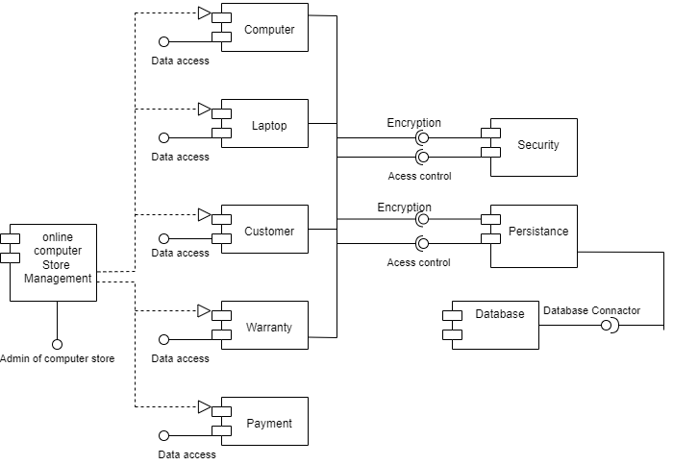

6.Activity diagram: -

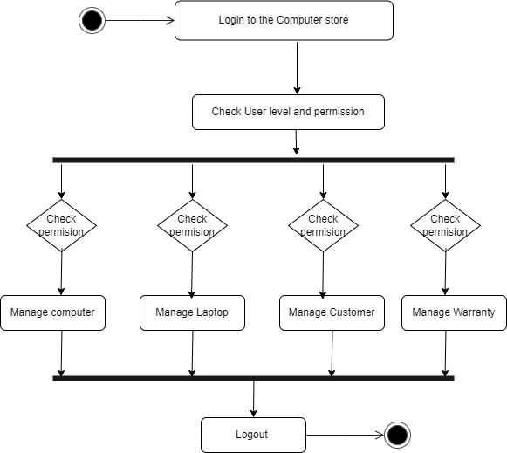

7.Deployment Diagram: -

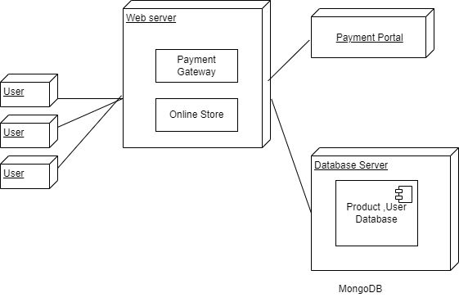

Online computer store

Chapter no.4
File Design

VPASC Baramati |  | 29

Data Dictionary:

Field Name | Data Type | Size | Description | Constraints
C_ id | INT | 5 | Unique ID for each customer | Primary key, Auto Increment
C_ name | VARCHAR | 15 | Customer’s full name | NOT NULL
C_ address | VARCHAR | 20 | Address of customer | NOT NULL
C_ phone | INT | 10 | Customer’s phone number | NOT NULL,  unique
A _id | INT | 5 | Unique ID for admin | Primary key, Auto Increment
A _name | VARCHAR | 15 | Name of admin | NOT NULL
A _email | VARCHAR | 10 | Email of admin | NOT NULL,  unique
Cat_ id | INT | 15 | Unique category id | Primary key,Auto Increment
Cat_ name | VARCHAR | 10 | Category name/type | NOT NULL
Cat_ desc | VARCHAR | 11 | Category description | NOT NULL
rid | INT | 15 | Unique Review id | Primary key, Auto Increment

Field Name | Data Type | Size | Description | Constraints
rating | VARCHAR | 5 | Rating of product | NOT NULL
R_ text | VARCHAR | 30 | Review description | NOT NULL
R_ date | DATE | 8 | Review date | NOT NULL
P_ id | INT | 3 | Unique product ID | Primary key,Auto Increment
P_ name | VARCHAR | 30 | Product name | NOT NULL
P_ price | INT | 5 | Product price | NOT NULL
O_ id | INT | 5 | Unique order ID | Primary key, Auto Increment
O_ date | DATE | 8 | Date of order placement | NOT NULL
O_ status | VARCHAR | 10 | Order status | NOT NULL
B_ no | INT | 5 | Unique bill number | Primary key, Auto Increment
B_ date | DATE | 8 | Billing date | NOT NULL
Total | INT | 5 | Total bill amount | NOT NULL
Car_ tid | INT | 5 | Unique employee number | Primary key, Auto Increment
Qty | VARCHAR | 20 | Employee name | NOT NULL
Added_ date | INT | 10 | Employee mobile number | NOT NULL, unique

Field Name | Data Type | Size | Description | Constraint
C_ status | VARCHAR | 20 | Cart status | NOT NULL
C_ id | INT | 5 | Customer id | Foreign key constraint
P_ id | INT | 3 | Product id | Foreign key constraint

Data Flow :

Process Name | Description | Input Process | Output Process
Admin & Customer  registration and Account Creation | System verifies credentials against the Login File | User sign-up | Account Created
Browse & Select Product | System manages & update stock and select product | Product Details  & Manages Stock | Select Product & Updates Stock
Place order | System generates o_id, stores order details | Place An order | Billing generation
Bill generation | System calculates total amount and generates bill and report | Assist the bill report | Keep track of bill & report
Report Generation | This Process generates the Report File | Bill Details | Generate Report File

Data Store:

Data store name | Description | Data flow In | Data flow Out
Customer _muster | Stores permanent customer details | This flow has data flow in level 1.0 | Data flow out in 5.0 for bill generation
Admin _muster | Stores admin user details | This file has data flow in level 2.0 | Data flow out in 5.0 for bill generation
Account _muster | Stores account information | This flow has data flow in level 1.0 | Data flow out in 5.0 for bill generation
Product_ muster | Stores details of all products | This flow has data flow in level 3.0 | Data flow out in 5.0 for bill generation
Employee _muster | Stores employee details | This file has data flow in level 3.0 | Data flow out in 5.0 for bill generation
Bill _muster | Stores bill details | This file has data flow in level 4.0 | Data flow out in 5.0 for bill generation
Report _muster | Stores details of report | - | Data flow out in 5.0 for bill generation

Data Process:

Process Name | Description | Input Process | Output Process
Admin & Customer  registration and Account Creation | System verifies credentials against the Login File | User sign-up | Account Created
Browse & Select Product | System manages & update stock and select product | Product Details  & Manages Stock | Select Product & Updates Stock
Place order | System generates o_ id, stores order details | Place An order | Billing generation
Bill generation | System calculates total amount and generates bill and report | Assist the bill report | Keep track of bill & report

Online computer store

Chapter no.5
Table Design

VPASC Baramati |  | 36

Column Name | Data Type | Constraints
C_ id | INT | Primary Key, Auto Increment
C _name | VARCHAR | NOT NULL
C _address | VARCHAR | NOT NULL
C _phone | VARCHAR | NOT NULL
C _email | VARCHAR | NOT NULL, Unique
Column Name | Data Type | Constraints
A_ id | INT | Primary Key, Auto Increment
A_ name | VARCHAR | NOT NULL
A_ email | VARCHAR | NOT NULL, Unique
A_ phone | VARCHAR | NOT NULL
Column Name | Data Type | Constraints
Cat_ id | INT | Primary key, Auto Increment
Cat name | VARCHAR | NOT NULL
Cat desc | VARCHAR | NOT NULL
Column Name | Data Type | Constraints
Rid | INT | Primary Key, Auto Increment
Rating | VARCHAR | NOT NULL
R_ text | VARCHAR | NOT NULL
R date | DATE | NOT NULL
C_ id | INT | Foreign Key constraint
P_ id | INT | Foreign Key constraint
Table Design: -

1]Customer:

2]Admin:

3]Category:

4]Review:

Column Name | Data Type | Constraints
P id | INT | Primary Key, Auto Increment
P_ name | VARCHAR | NOT NULL
P_ price | INT | NOT NULL
P_ model | INT | NOT NULL
Column Name | Data Type | Constraints
O _id | INT | Primary Key, Auto Increment
O _date | DATE | NOT NULL
O _status | VARCHAR | NOT NULL
O_ type | VARCHAR | NOT NULL
Column Name | Data Type | Constraints
B _no | INT | Primary Key, Auto Increment
B_ date | DATE | NOT NULL
Gst _no | INT | NOT NULL
Total | INT | NOT NULL
Column Name | Data Type | Constraints
Cart_ id | INT | Primary Key, Auto Increment
qty | INT | NOT NULL
Added _date | DATE | NOT NULL
C_ status | VARCHAR | NOT NULL
C_ id | INT | Foreign Key constraint
P_ id | INT | Foreign Key constraint
5]Product:

6]Order:

7]Bill:

8]Cart:

Chapter: - 6
Form Design and Report

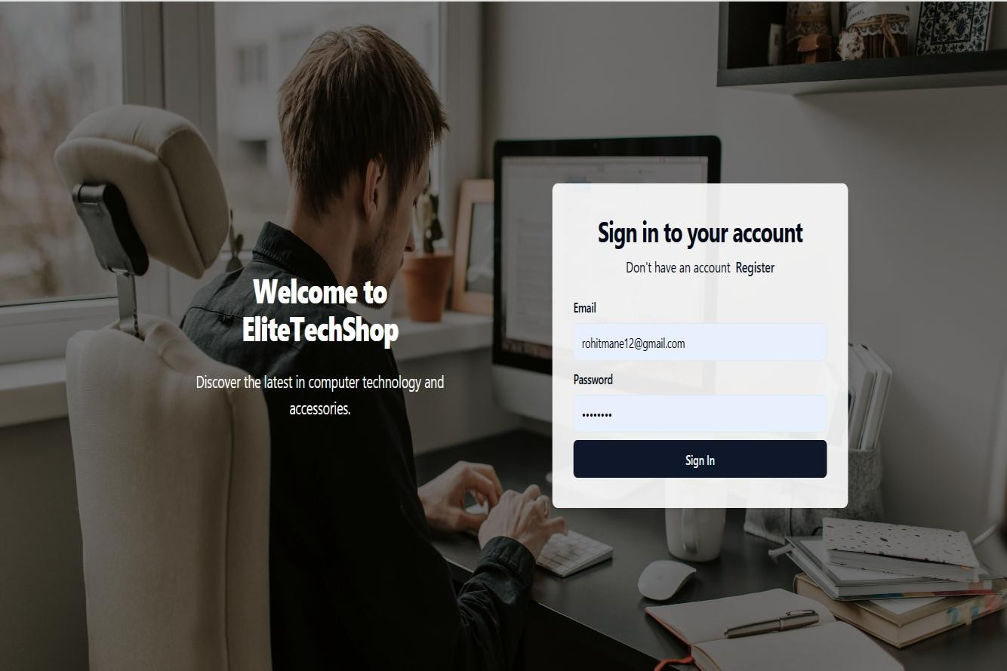
Sign page:

Home page :-


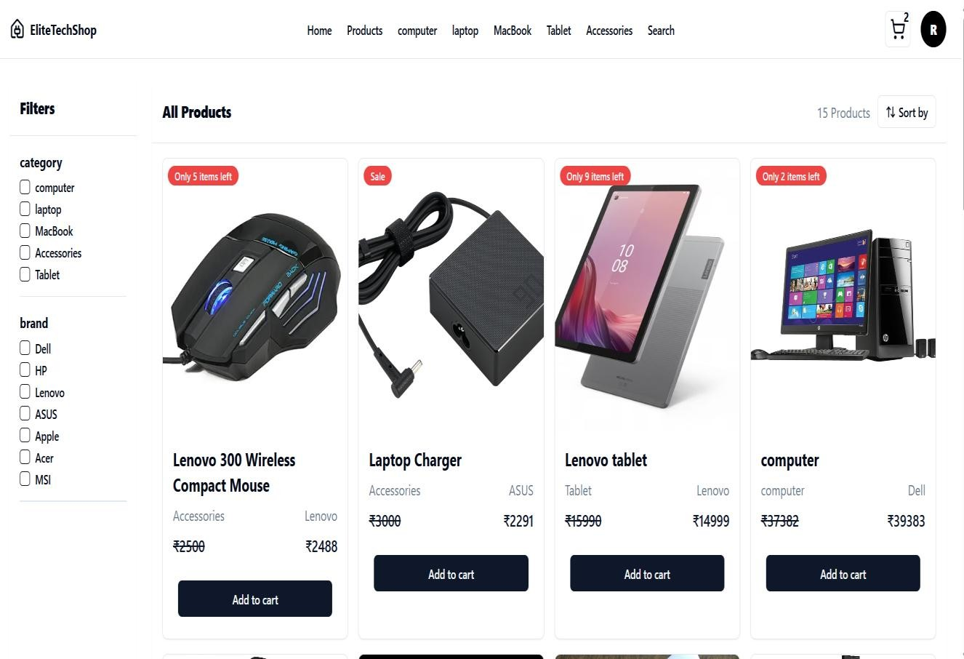
Product page :-

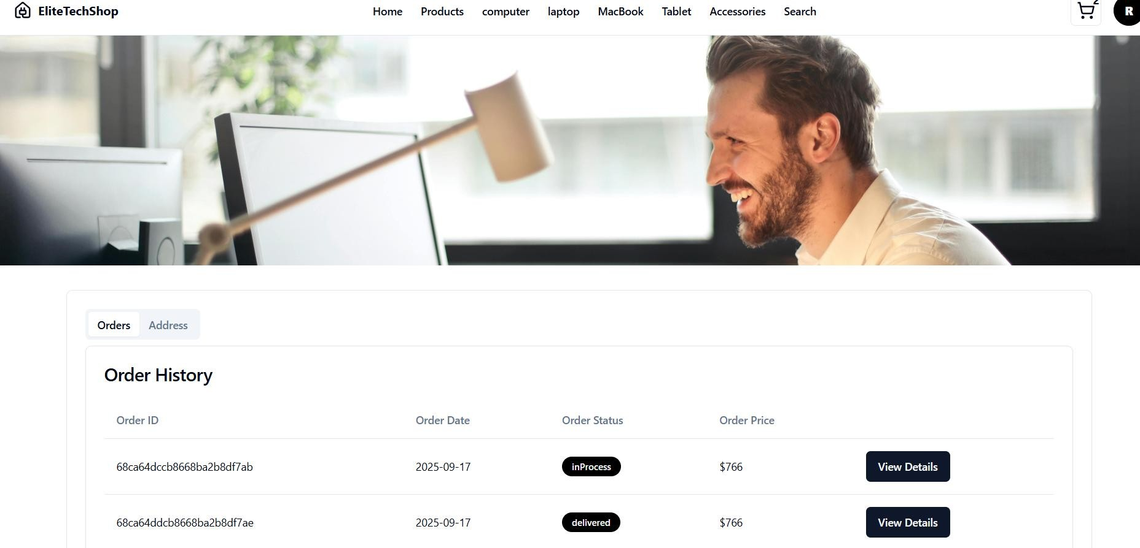
User Account page:-

Admin Panel page :-

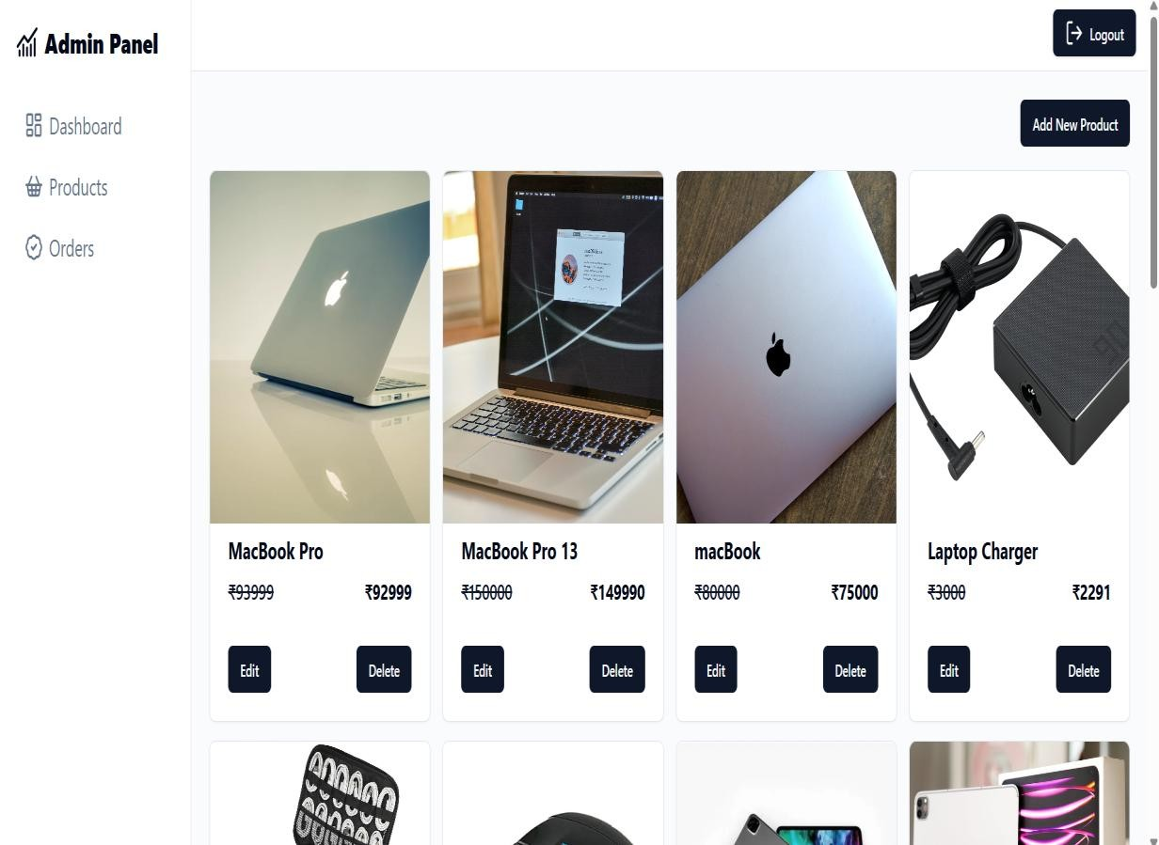

Chapter no.7

Advantages & Disadvantages

Advantages –
- Wide Product Range
Handles multiple categories like laptops, desktops, accessories, and computer components with detailed specifications.
- Inventory Management
Automatically updates stock after each purchase, helping prevent out-of-stock or overstock situations.
- Secure Online Payments
Integration with PayPal and other gateways ensures safe and reliable transactions for customers.
- Customer Data Management
Stores customer profiles, order history, and preferences for personalized recommendations, offers, and loyalty programs.
- Reports & Analytics
Provides detailed reports on sales, revenue, top-selling products, and customer trends to support business decisions.
- Time-Saving & Convenience
Customers can shop 24/7 from anywhere without visiting a physical store, reducing effort and increasing satisfaction.

Disadvantages –
- Initial Setup Cost
Developing and deploying a MERN-based online store with hosting, domain, and database setup can be costly initially.
- Training Required
Admins and staff may require training to manage the backend, update products, and handle customer queries.
- Maintenance & Updates
Regular technical maintenance, bug fixing, and feature updates require ongoing resources.
- Dependence on Internet & Servers
The system depends on stable internet and hosting servers. Any downtime can disrupt sales operations.
- Data Security Risks
Customer data, payment details, and business information must be secured against potential cyber threats and hacking attempts.
- Technical Complexity
Compared to a physical store, running an online store requires technical expertise for deployment, scaling, and integration with third-party services.

Online computer store

Chapter no.8
Future Enhancement

VPASC Baramati |  | 48

Future Enhancement:
- Advanced Inventory Management
- Customer Relationship Management (CRM)
- Online Store Integration
- Multiple Payment Options
- AI & Analytics
- Multi-User & Role-Based Access
- Mobile App Support
- Cloud Backup & Security
- Integration with Marketing Tools
- Multi-Store Management

Online computer store
Chapter no.9
Bibliography

VPASC Baramati |  | 50
Website:
  - www.google.com
  - www.youtube.com
  - www.chatgpt.com
  - www.w3schools.com

Books References: -
- Learning JavaScript Data Structures and Algorithms" by Loiane Groner
- "MongoDB: The Definitive Guide" by Kristina Chodorow
- "React Up & Running" by Stoyan Stefanov
- "Node.js Design Patterns" (3rd Edition)

